Adam Zeigler

Assignment 1

?how do I add the images?

1. "INSERT INTO category (cat_ID, cat_Name, cat_SubCat) VALUES (‘$cat_ID’,’$cat_Name’,’$cat_SubCat’)";

"INSERT INTO category (cat_ID, cat_Name, cat_SubCat) VALUES (‘15’,’Vice’,’1’)";

1. "INSERT INTO product (pro_ID, pro_Name, pro_Descript, pro_Price, pro_Qty, pro_Manufacturer, pro_Model, cat_Id, pro_Feat, pro_Weight) VALUES (‘$pro_ID’, ‘$pro_Name’, ‘$pro_Descript’, ‘$pro_Price’, ‘$pro_Qty’, ‘$pro_Manufacturer’, ‘$pro_Model’, ‘$cat_Id’, ‘$pro_Feat’, ‘$pro_Weight’)";

"INSERT INTO product (pro_ID, pro_Name, pro_Descript, pro_Price, pro_Qty, pro_Manufacturer, pro_Model, cat_Id, pro_Feat, pro_Weight) VALUES (‘13’,’Vice_Grip’,’ 24sp 24" Locking Clamp with Swivel Pads 24SP’,’ 29.17’,’10’,’ Irwin’,’ Standard’,’ 15’,’ N’,’ 57.12’)";

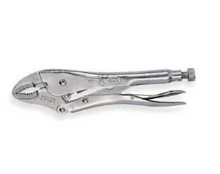

"INSERT INTO product (pro_ID, pro_Name, pro_Descript, pro_Price, pro_Qty, pro_Manufacturer, pro_Model, cat_Id, pro_Feat, pro_Weight) VALUES (‘14’,’Vice-Grip Locking pinch’,’ Pinches off and locks on to tubing, leaving both hands free to do other work, Turn screw to adjust pressure and fit work. Stays adjusted for repetitive use, Constructed of high-grade heat-treated alloy steel for maximum toughness and durability, Guarded release trigger quickly unlocks and protects from accidental release.’,’ 11.99’,’5’,’Wilton’,’Standard’,’15’,’N’,’14.08’)";

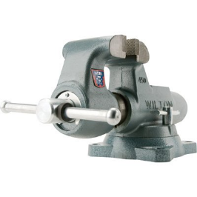

"INSERT INTO product (pro_ID, pro_Name, pro_Descript, pro_Price, pro_Qty, pro_Manufacturer, pro_Model, cat_Id, pro_Feat, pro_Weight) VALUES (‘15’,’Vice Spring’,’ Vise Grip Replacement spring for 10R, 10WR, 10CR, 11R, 11SP, 11HD, 20R, 310S, 12LC, and 10LW locking tools’,’ 1.65’,’4’,’Irwin’,’Standard’,’15’,’N’,’ 1.60’)";

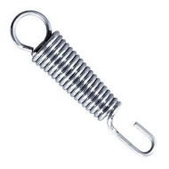

"INSERT INTO product (pro_ID, pro_Name, pro_Descript, pro_Price, pro_Qty, pro_Manufacturer, pro_Model, cat_Id, pro_Feat, pro_Weight) VALUES (‘16’,’Vice Nippers’,’ Induction hardened cutting edge stays sharp longer, precision matched jaws provide a clean cut’,’ 14.86’,’7’,’Kurt’,’Standard’,’15’,’N’,’ 17.60’)";

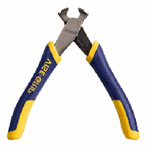

1. "INSERT INTO prodopt (opt_ID, opt_Group, opt_Name, opt_Value, opt_Price, pro_ID) VALUES (‘$opt_ID’, ‘$opt_Group’,’ $opt_Name’, ‘$opt_Value’, ‘$opt_Price’, ‘$pro_ID’)";

"INSERT INTO prodopt (opt_ID, opt_Group, opt_Name, opt_Value, opt_Price, pro_ID) VALUES (‘5’, ‘4’,’ Vise-Grip 36sp 36"’, ‘36’, ‘4.00’, ‘13’)";

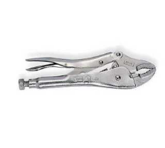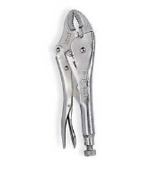

"INSERT INTO prodopt (opt_ID, opt_Group, opt_Name, opt_Value, opt_Price, pro_ID) VALUES (‘6’, ‘4’,’ Vise-Grip Nippers 30’, ‘30’, ‘7.00’, ‘16’)";

